Getting Started with the Raspberry Pi
Introduction
Raspberry Pi is developed by a British charitable organization named Raspberry Pi foundation. It is a card computer designed for students’ programming, and the size is only like a credit card, the system is based on Linux (Debian).
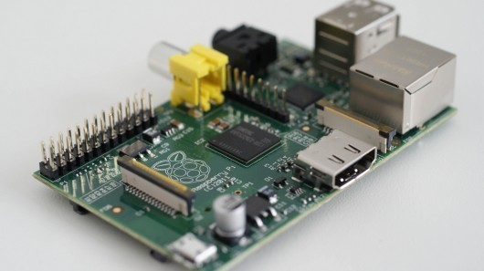
We can do many things with the Raspberry Pi, for example, listen to music, watch films and handle official business. These are just the most common functions. We can use it to control our equipment or collect sensors’ data, so we can use it to make our own intelligent household, may be this is the most attractive place.
The most basic condition should be provided before you start your project with Raspberry Pi, a mouse, a keyboard, a network cable, a SD card and a display, etc…
Starting your travel of Raspberry Pi
For the first time, it is essential for you to build development environment. To achieve this, you should take the following measures.
- Download the image of operation system.
http://www.raspberrypi.org/downloads
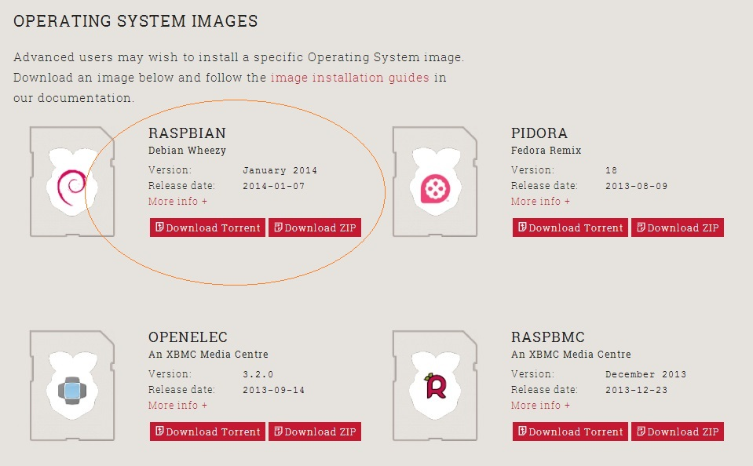
We recommend Raspbian for you if you are a beginner.
- Download Win32DiskImager if you are a windows user.
- Unzip the OS (2014-01-07-wheezy-raspbian.zip).
- Run Win32DiskImager, select 2014-01-07-wheezy-raspbian.img and appropriate drive (be careful). Click Write.
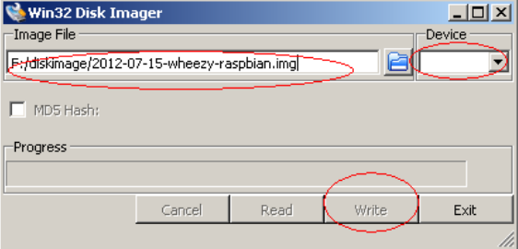
- After finishing writing, plug a SD card to Raspberry Pi and connect mouse, keyboard, network cable and HDMI.
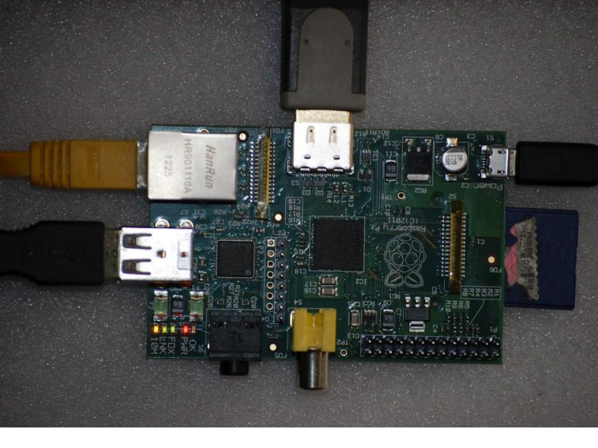
- Power on Raspberry Pi (The green led flash indicate that the SD card is available). Next, you will see the startup picture if your connection is right.
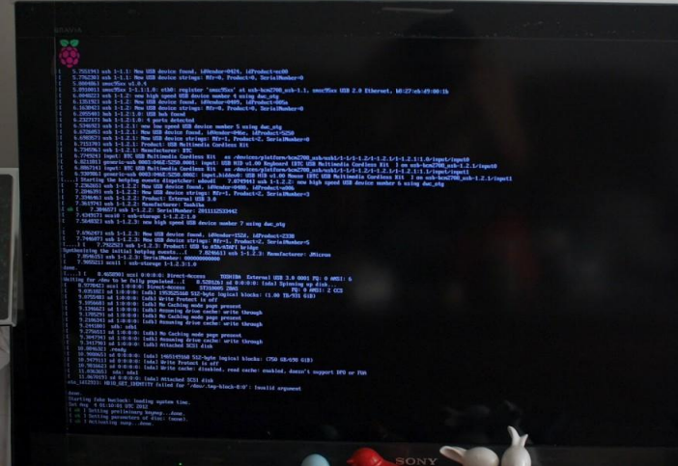
- Waiting for a while, you will see a configuration UI if you use Raspberry Pi for the first time, and the configuration UI will be activated in future by the command of raspi-config.
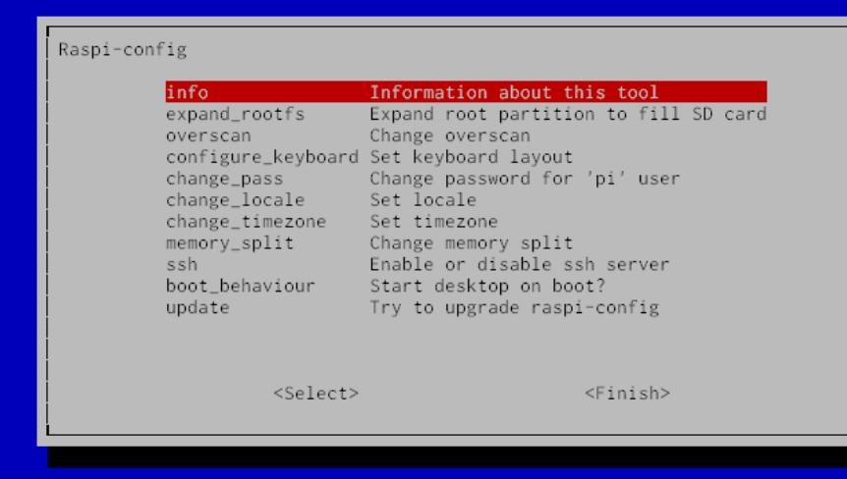
￭ expand_rootfs – expand root partition to the whole SD card as we need enough space to install applications.
￭ overscoverscan – expand or narrow display area of the screen. Make the picture full of the screen.
￭ configure_keyboard – This is very important. If you do not configure it, maybe your keyboard cannot work normally.
Setup your network
sudo nano /etc/network/interfaces
auto lo
iface lo inet loopback
iface eth0 inet dhcp
auto wlan0
allow-hotplug wlan0
iface wlan0 inet dhcp
wpa-ssid “your wifi name”
wpa-psk “your wifi password

Setup static IP
sudo nano /etc/network/interfaces
auto lo
iface lo inet loopback
iface eth0 inet dhcp
allow-hotplug wlan0
iface wlan0 inet manual
wpa-roam /etc/wpa_supplicant/wpa_supplicant.conf
iface default inet static
address 192.168.1.2
netmask 255.255.255.0
gateway 192.168.1.1
dns-nameservers your DNS-server IP

Test network
ping www.google.com
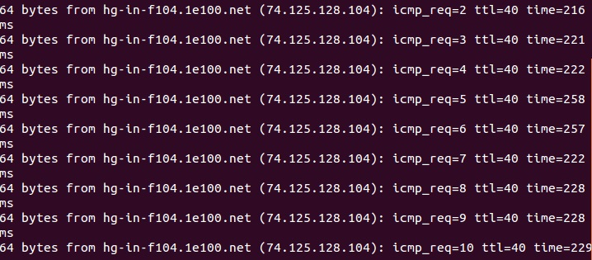
If you see the above result, it means your network configuration is correct.
Install vim
sudo apt-get install vim

Install RPi.GPIO(Python)

Install python-dev

sudo aptitude install python-dev

Install RPi.GPIO

wget http://raspberry-gpio-python.googlecode.com/files/RPi.GPIO-0.5.3a.tar.gz

tar xvzf RPi.GPIO-0.5.3a.tar.gz

cd RPi.GPIO-0.5.3a

sudo python setup.py install

Test：

New a led.py
- #!/usr/bin/env python
- # -*- coding: utf-8 -*-
- import RPi.GPIO as GPIO
- import time

- GPIO.setmode(GPIO.BOARD)
- # need to set up every channel which are using as an input or an output
- GPIO.setup(11, GPIO.OUT)

- while True:
- GPIO.output(11, GPIO.HIGH)
- time.sleep(1)
- GPIO.output(11, GPIO.LOW)
- time.sleep(1)

Run:

sudo python led.py

Install wiringPi(Rpi GPIO C Library)
sudo apt-get update
sudo apt-get upgrade
apt-get install git-core
git clone git://git.drogon.net/wiringPi
cd wiringPi
git pull origin
cd wiringPi
./build

Test whether wiringPi is installed successfully or not.
gpio -v
gpio readall

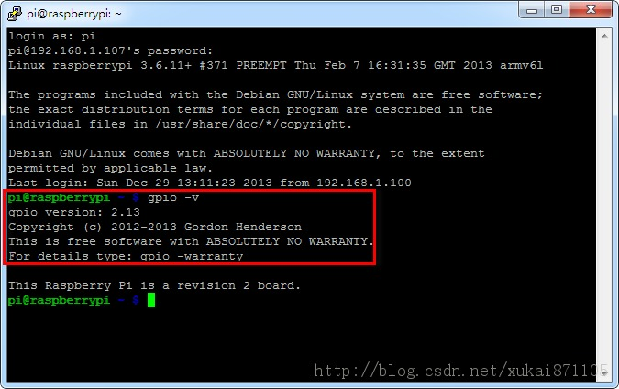
New a blink.c
- #include <wiringPi.h>
- main ()
- {
- wiringPiSetup () ;
- pinMode (0, OUTPUT) ;
- for (;;)
- {
- digitalWrite (0, HIGH) ; delay (500) ;
- digitalWrite (0, LOW) ; delay (500) ;
- }
- }
gcc -Wall -o blink blink.c –lwiringPi
Run:
sudo ./blink

Install BCM2835 C Library
Download from Internet
wget http://www.airspayce.com/mikem/bcm2835/bcm2835-1.35.tar.gz
tar xvzf bcm2835-1.35.tar.gz
cd bcm2835-1.35
./configure
make
sudo make check
sudo make install

new a blink.c
- #include <bcm2835.h>

- // Blinks on RPi Plug P1 pin 11 (which is GPIO pin 17)
- #define PIN RPI_GPIO_P1_11

- int main(int argc, char **argv)
- {
- if (!bcm2835_init())
- return 1;

- // Set the pin to be an output
- bcm2835_gpio_fsel(PIN, BCM2835_GPIO_FSEL_OUTP);

- // Blink
- while (1)
- {
- bcm2835_gpio_write(PIN, HIGH);
- bcm2835_delay(100);

- bcm2835_gpio_write(PIN, LOW);
- bcm2835_delay(100);
- }
- bcm2835_close();
- return 0;
- }
gcc -o blink blink.c -lbcm2835
sudo ./blink

Install FTP server and client
FTP is used to download files from other computer that is configured as FTP server.
vsftpd makes your Raspberry Pi become a FTP server.
sudo apt-get install ftp
sudo apt-get install vsftpd

The directory of your ftp server is /home/pi, it means that which files placed in /home/pi can be download by others.

